1.Create a new branch ‘css-assignments’.

2.Switch to ‘css-assignments’ branch.

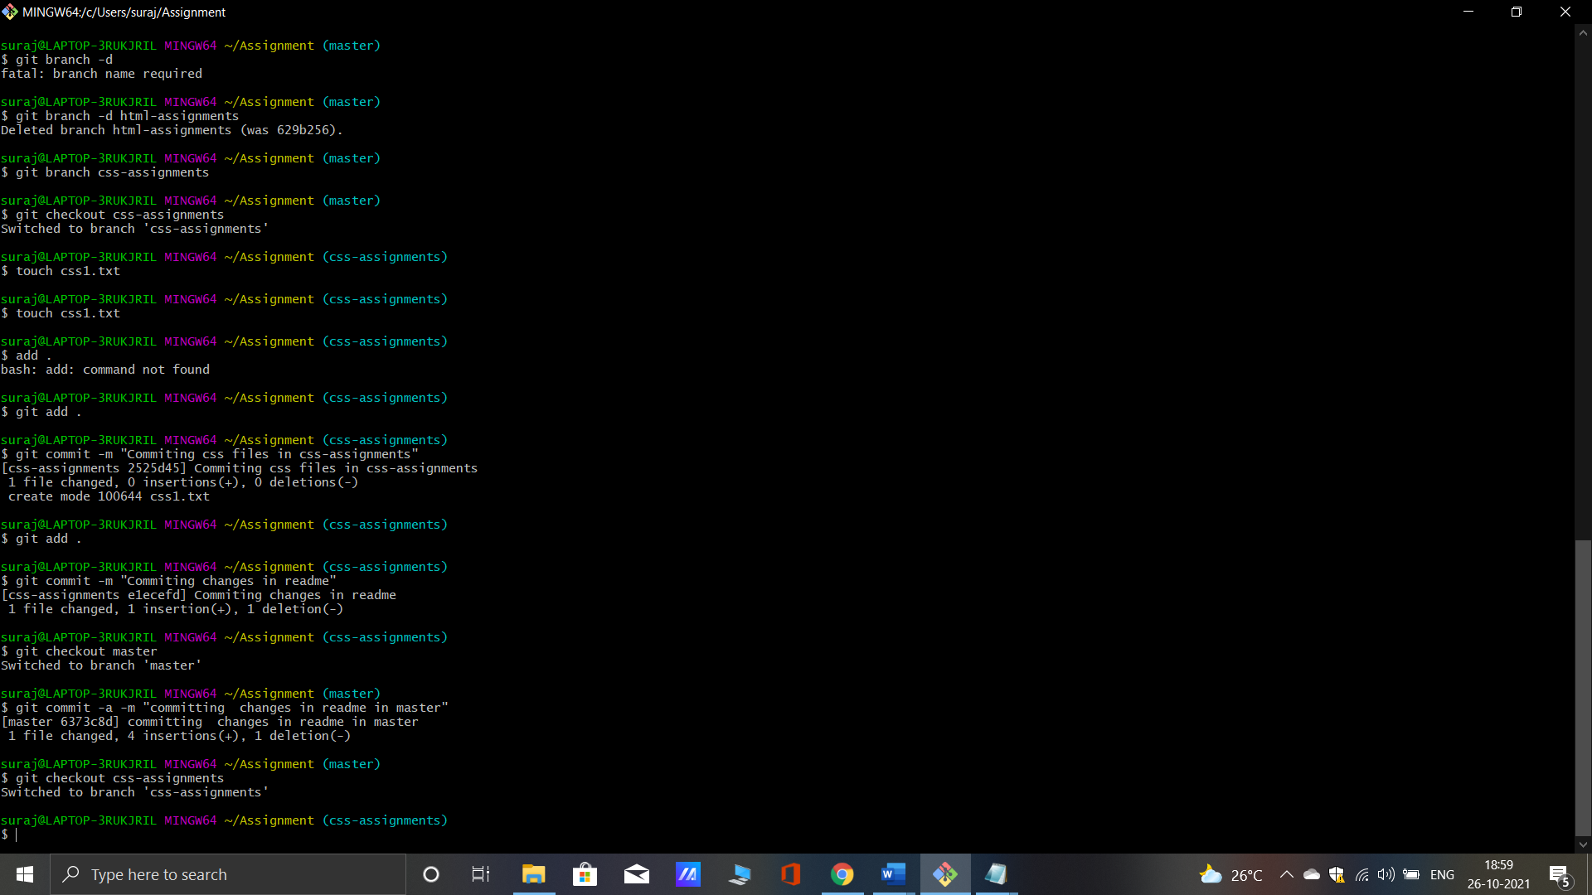

3. Copy all CSS assignments inside ‘Assignments’ folder.

4.Commit CSS assignments into ‘css-assignments’ branch.



5. Make minor changes into README.txt file on line 1 belonging to ‘css-assignments’ branch.

6.Commit those changed files.



7. Switch to master branch.

8.Make minor changes into README.txt file on line 3 & commit those changes into master.



9. Again switch to ‘css-assignments’ branch.

10.Make minor changes into few files belonging to ‘css-assignments’ branch.

11.Commit those changes



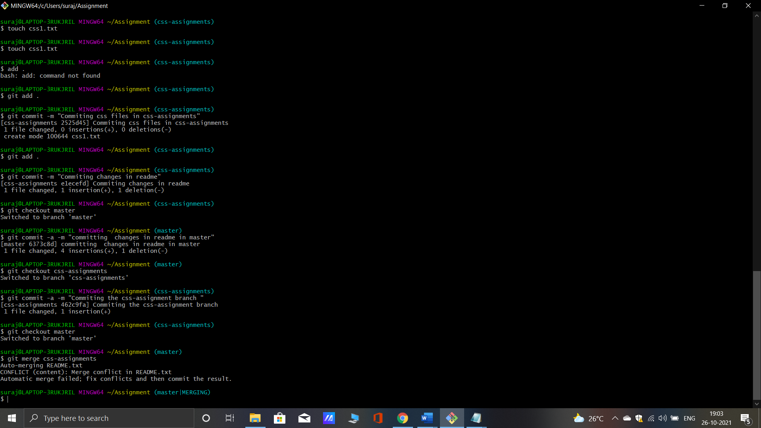

12. Switch to master.

13.Merge ‘css-assignments’ branch into master. Confirm all css assignments are shown in master.

14.Finally delete the ‘css-assignments’ branch.

